Access Reports currently run in order of usage
All Under Dottie2003
Optional Life – the smaller section below is the continuation of the rest of the bottom part of the report, it wouldn’t all fit on the screen.
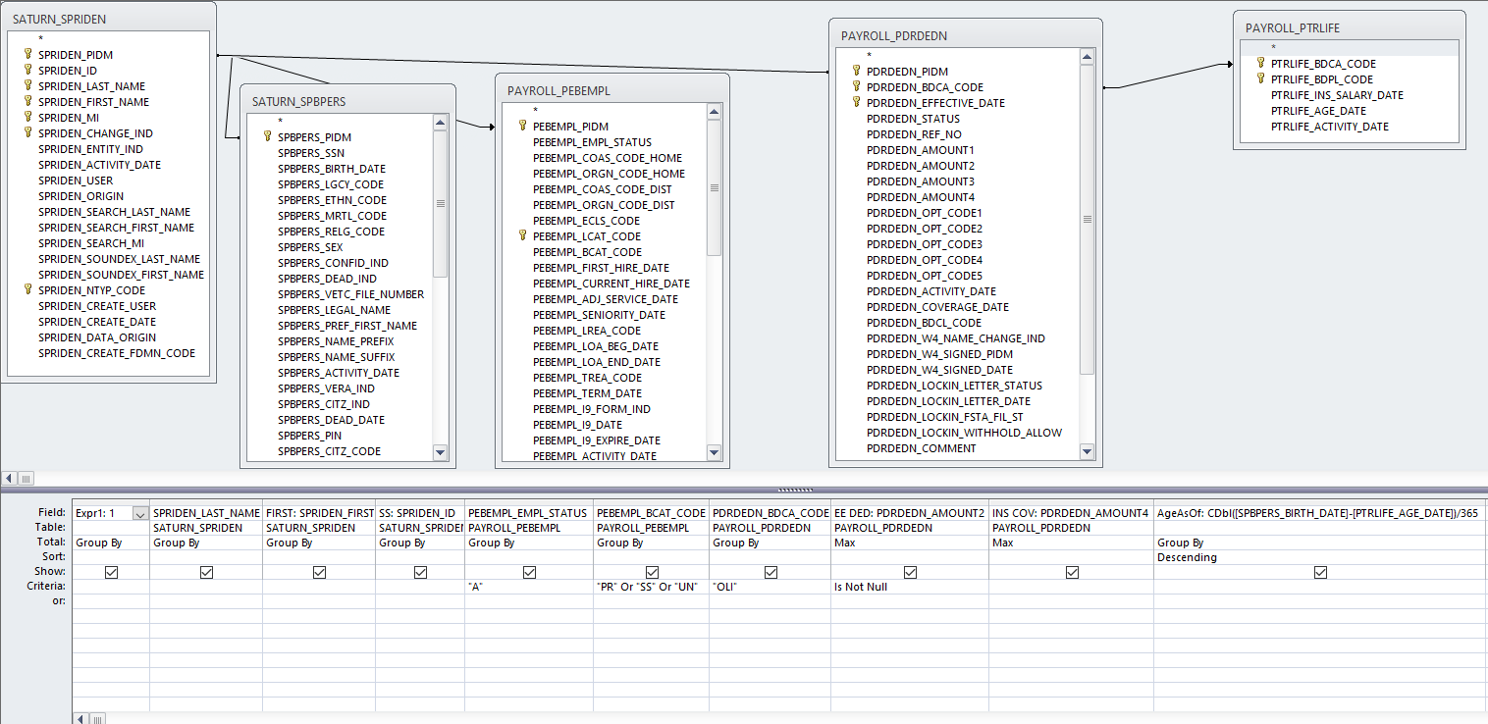
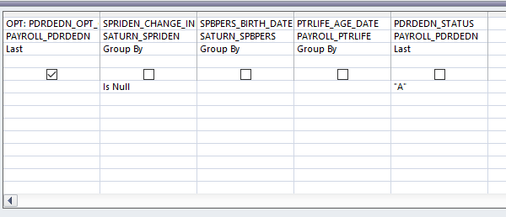
Used once a year and on occasion
10 over 10 – This report will be necessary to be able to choose more than one NBRJOBS_EFFECTIVE_DATE and more than one NBRJOBS_FACTOR
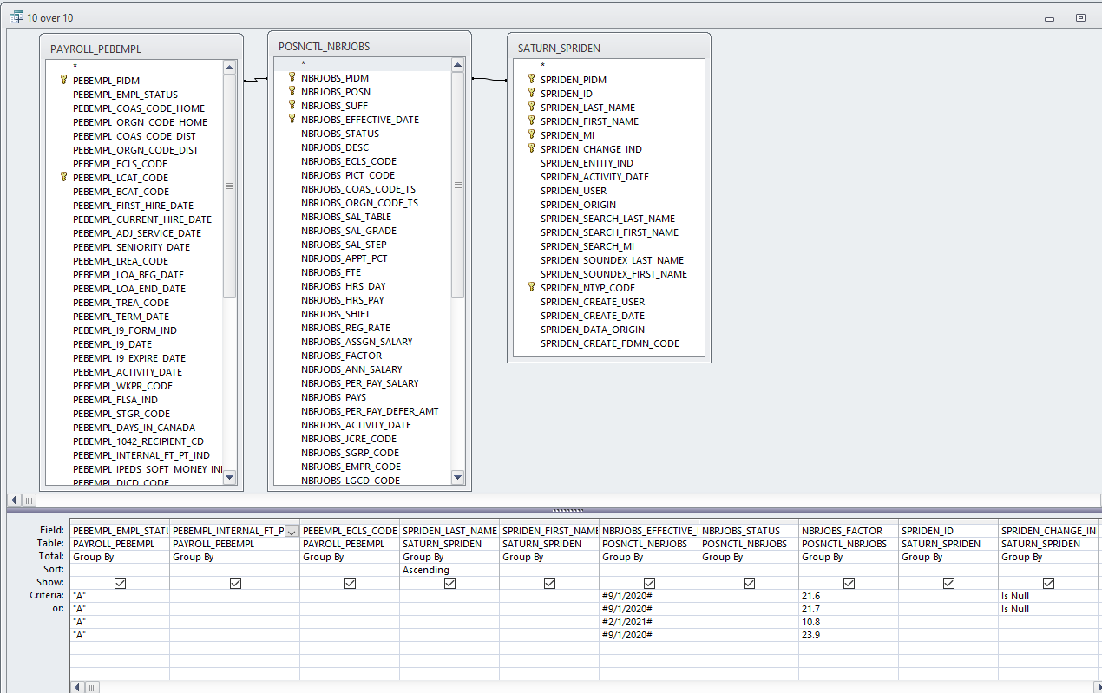

10 over 10 ded – The SPRIDEN_ID will be a spot where I would need to enter a particular C# in order to get their particular deductions. This might be good as an additional option in the above report instead of having two separate reports.
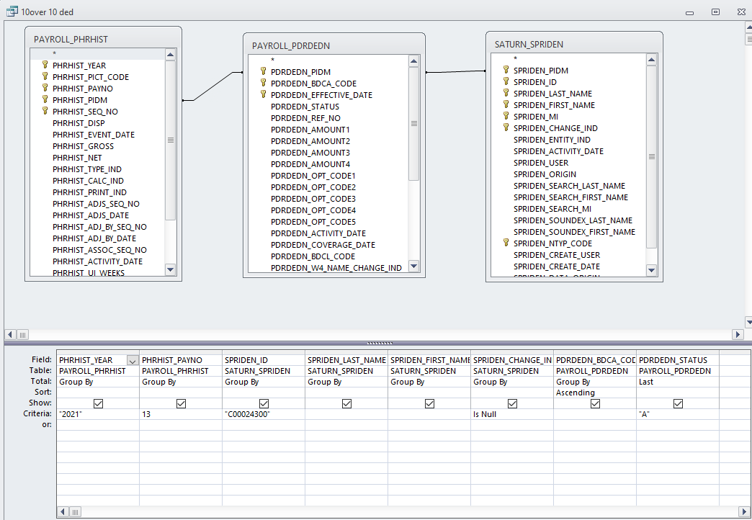

1 - 403 Limit – If new BENEFIT_DEDUCT_CODE_KEY are added, I’d need to be able to pick them up as well.
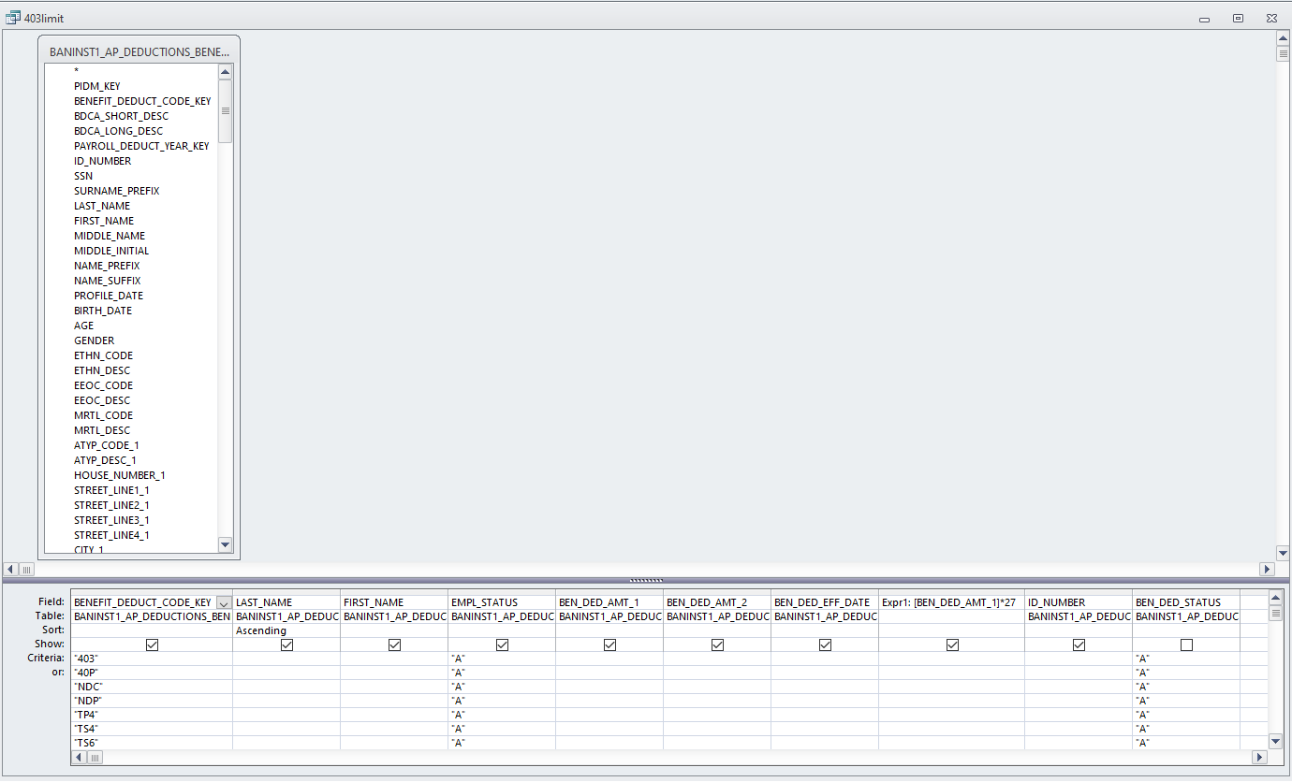

2 - Retirement 403 Limit – modify deductions, add limit (drededn_amount2)
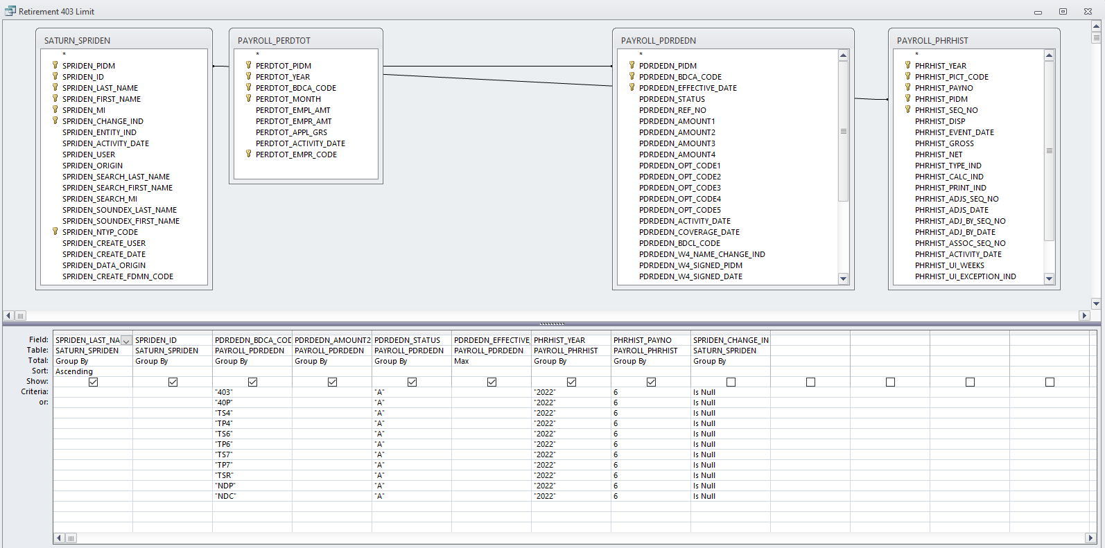

I’m not able to get either of these 403 Limit reports to run any more so I’m not sure if one is better than the other or if they are getting the same info – I’m just trying to get a list of all additional retirement deuctions so I can see what the current limit is – I need to update the limit yearly. Both of these reports do not have to be created, only one. I was just giving as much info as I could.

Workers Comp Audit – I update the Queries first that are titled the same as the reports, I need the final output to show the titles for the period of time I’m running (the period of time I run for is February 1 of previous year through January 31 of current year).

- Run reports in Access – Dottie Database
  - WC queries – update years for all WC/OT
  - WC reports – Design view to update dates @ top of page then run report for numbers
    - Workers Comp Audit All January Only
    - Workers Comp Audit All Total Wages
      - Highlight Student Services (Gorman & Duzy)
    - Workers Comp Audit All OT
      - Highlight Student Services (Gorman & Duzy)
    - Workers Comp Audit Union Total Wages
    - Workers Comp Audit Union OT
    - Workers Comp Audit Security Total Wages
    - Workers Comp Audit Security OT

As a side note on these – for 5 years I have used these reports, then last year the audit process changed and I no longer know what they even want from us for reporting – I think having these reports initially will be better than not having anything to go off of, but when they request an audit again this year, I may need additional info or just something added to these.

